**Project Synopsis**

On

“Car Speed Detection System”

Submitted by

Mr. Kazi Jawwad A Rahim (T-16-0020)

Ms. Nevgi Shivani Anil (TD-17-0417)

Ms. Hadkar Vinita Vilas (T-16-0298)

Under the Guidance of

Prof. Shete Suraj

Assistant Professor

Dept. of Electronics Engg.



**Department of IT Engineering**

**Finolex Academy of Management and Technology, Ratnagiri.**

|  |  |  |
| --- | --- | --- |
| **Finolex Academy of Management and Technology, Ratnagiri.**  **Project Synopsis**  **for**  **Department wise Best Project Award Competition** Academic year 2018-2019 | | |
|  | **Department** | Information Technology |
|  | **Name of Program** | T.E.(Information Technology) |
|  | **Project Topic** | Car Speed Detection System |
|  | **Name and Signature of Students** | 1. Mr. Kazi Jawwad A Rahim _________ 2. Ms. Nevgi Shivani Anil _________ 3. Ms. Hadkar Vinita Vilas _________ |
|  | **Name and Signature of Guide** | Prof.Shete Suraj _________ |

**CONTENTS**

Page No.

*Participant’s Declaration* *i*

*Acknowledgement* *ii*

*List of Figures* *iii*

*List of Tables* *iv*

*Nomenclature* *v*

*Abstract vi*

**Chapter 1: INTRODUCTION**

**Chapter 2:LETERATURE REVIEW**

**Chapter 3:PROJECT WORK** 1

**Chapter 4: RESULTS AND DISCUSSION**

**Chapter 5: CONCLUSIONS AND FUTURE SCOPE**

**REFERENCES**

**DECLARATION**

We declare that, this written submission represents our ideas in our own words and where others ideas or words have been included, we have adequately cited and referenced the original sources. We also declare that we have adhered to all principles of academic honesty and integrity and have not misrepresented or fabricated or falsified any idea/data/fact/source in our submission. We understand that any violation of the above will be cause for disciplinary action by the Institute and can also evoke penal action from the sources which have thus not been properly cited or from whom proper permission has not been taken when needed.

Mr. Kazi Jawwad A Rahim

Ms. Nevgi Shivani Anil

Ms. Hadkar Vinita Vilas

**ABSTRACT**

We are intending to develop the car speed detection system using Arduino UNO board, IR Sensors, Bread board and Cables. This system will allow us to detect accurate speed. This system will give us a broad view to deploy the project in real life. The speed limit is pre-defined by traffic regulatory system. With the help of IR sensor, we can get speed in terms of either kmph or mph. To view the speed of the car, we have to connect our circuit with Computer or Laptop.

**Keywords** –

1. Bread board
2. IR Sensors
3. Jumping Cables
4. Arduino UNO board

**1. INTRODUCTION**

* 1. **Introduction:**

Over speed is crucial issue nowadays. Most of the vehicles runs beyond the speed limit. To prevent people from breaking rules, it is necessary to have a good implementation of technology through which we can avoid misuse of laws. One solution to this situation can be digital Car Speed Detection System. We will build a system with the help of Arduino UNO board, IR Sensors, Bread board and Cables. We will also require a cable for connecting Arduino UNO board with Computer or Laptop. We will keep distance between two IR Sensors as 6 cm. We will provide VCC and Ground to IR Sensor from Arduino UNO board. We will read the output on computer screen in Serial Monitor of Arduino IDE. This system will give appropriate speed. This will help us to detect vehicle which breaks rules applied in accordance with road safety. We can take strict action against them.

* 1. **Aim and Objectives:**

The system must be capable of following line:

* It should be capable of tracking speed.
* The system must be capable of following a line even if it is breaks.
* The system must be reliable.
* Scalability must be a primary concern in the design.
  1. **Problem Definition:**

Vehicles are important part of our day to day life. We are surrounded with vehicles. These vehicles help us to reach to our destination on time. But sometime these vehicles become the cause of death. Mostly this happen due to over speeding. To avoid such accidents, it is necessary to develop a system, which will capture the vehicles whosever break rules. Also, there should be hard rules to prevent such incidents.

* 1. **Scope of Project:**

Our system will provide an efficient approach towards developing an environment where everyone will obey rules and regulations regarding road safety. We will capture vehicles whosever will overspeed and will report to nearby monitor to take strict action. In future, we can use camera device to identify the vehicle accurately to take proper action.

**2. LITERATURE REVIEW**

As IR Sensors and Sound Sensor being the core disciplines of the today’s world technology field. Many technologies are available to measure speed of travelling car. One of the technologies can be by using hardware sensors in the car itself. It supposed to have speed sensors in the car which detect the rotations per minute of the car. This can be used to detect the speed of the car and then transfer it wirelessly [1]. Other technology could be LIDAR technology. It is the technology used in the speed guns held by the police personnel to check the speed of the moving car [1]. Also, image differentiation is used in the vehicle detection process. By using basic scientific velocity theory, they proposed they can calculate the speed of moving vehicle in the video scene from the known distance and time, which the vehicle has moved beyond [2]. Also, a technology in which moving vehicle video from any video camera or mobile source is utilized. The algorithms are implemented in C language using OpenCV and Visual Studio. Later this code can be ported to a simple processor, where vehicle speed can be measured. E.g. A simple smart phone with average processing capacity [3]. A system that will check on rash driving by calculating the speed of vehicle using the time taken to travel between the two set points at a fix distance. A set point consists of pair of sensors comprising of an IR transmitter and IR receiver, each of which are installed on either side of road. The time taken by the vehicle to travel from one set point to the other is calculated by control circuit. Based on the time it then calculates speed and displays that on seven segment displays. Moreover, if the vehicle crosses the speed limit, a buzzer sound alerting the police [4]. A system consisting of two modulated infrared emitters at the receiver consists of photodiode with an optical filter. Both mounted above the plane of detection. Laser beam will be reflected in the pavement and detected by the photodiode. This signal will be amplified and filtered to discard other optical signals different than 1kHz modulated laser and then, processed by computational software for analysis. Every time a vehicle crosses through the infrared light beam path, the system will count it and obtain the occupancy [5]. A system with new type of traffic and flash flood sensors based on combination of ultrasonic rangefinder with one or multiple passive infrared temperature sensors. This sensor combination can be used as a backbone for dual urban traffic flash flood wireless sensor network, since it can monitor vehicle speed counts, density and vehicle types as well as pluviometry water presence and water level with relatively high accuracy [6]. But these systems are proposing expensive techniques and security.

**3. PRESENT WORK**

We have to implement a system that will work efficiently with convenient expense. We have to only detect speed of moving car with noise generating by that car. So, in this paper we are invented such type of system where we can detect speed of moving car and noise generating by that car using Arduino UNO board, IR sensors, bread board and some cables. By implementing this system, we are allowed to calculate accurate speed of that car.

Arduino UNO

IR Sensor

End User

IR Sensor

1. **RESULTS**

**Source Code:**

int sen1=9;

int sen2=8;

unsigned long t1=0;

unsigned long t2=0;

float velocity;

void setup()

{

pinMode(sen1,INPUT);

pinMode(sen2,INPUT);

Serial.begin(9600);

}

void loop()

{

while(digitalRead(sen1));

while(digitalRead(sen1)==0);

t1=millis();

while(digitalRead(sen2));

t2=millis();

velocity=t2-t1;

velocity=velocity/1000;//convert millisecond to second

velocity=(6.5/velocity);//v=d/t

velocity=velocity*3600;//multiply by seconds per hr

velocity=velocity/1000;//division by meters per Km

Serial.print("Speed=");

Serial.print(velocity);

Serial.println(" Km/hr");

delay(1000);

}

System Setup:

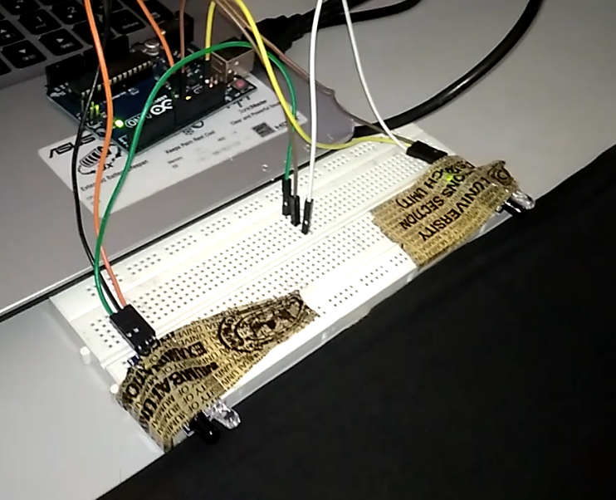

Output When Vehicle Passes:

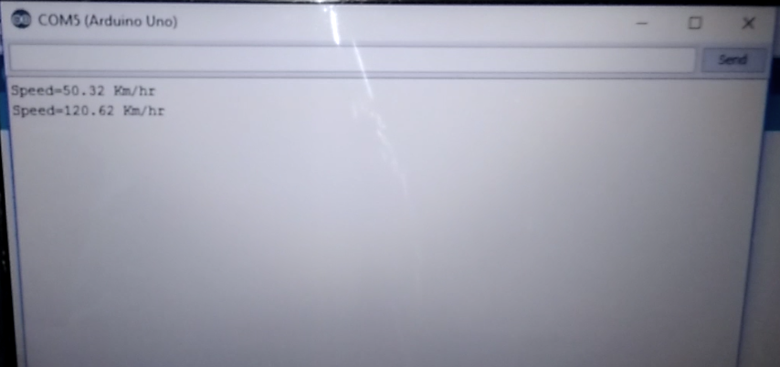

1. **Conculsions and future scope**

In this we have only detected speed generated by the car but in upcoming days we will implement the system which is an auto-triggered report about the over speeding and over honking to the nearest traffic police along with number of the car. Also, we will implement sound sensor, to measure noise pollution. Also, we will use camera surveillance to measure any impropriate action. This will improve our proposed system to be more secured and better as it will easily handle the situation.

1. **References**

**Journal References**

1. Sumit Deshpande, Vishant Bhole, Pradnya Dhudhade , Neha Gourkar, Prof. Santosh Darade “Implementing a system to detect over speeding and inform authorities in case of any violations” in International Research Journal of Engineering and Technology.
2. Chomtip Pornpanomchai, Kaweepap Kongkitisan “Vehicle Speed Detection System” in International Conference On Signal and Image Processing Applications.
3. Kiran Kumar KV, Pallavi Chandrakant, Santosh Kumar, Kushal KJ “Vehicle Speed Detection in Video frames using Corner Detection” in International Conference on Signal and Image Processing.
4. Monika Jain, Pravin Kumar, Priya Singh, Chhavi Narayan Arora, Ankita Sharma “Detection of Over Speeding Vehicles on Highways” in International Journal of Computer Science and Mobile Computing.
5. Moisѐs Rivas-López, Carlos A. Gomez-Sanchez, Javier Rivera-Castillo, Oleg Sergiyenko, Wendy Flores-Fuentes, Julio C. Rodriguez-Quiñonez, Pedro Mayorga-Ortiz “Vehicle Detection Using an Infrared Light Emitter and a Photodiode as Visualization System” in International Conference on Mobile Ad Hoc and Sensor System.
6. Enas Oudat, Mustafa Mousa, Christian Claudel “Vehicle Detection and Classification Using Passive Infrared Sensing” in International Conference on Mobile Ad Hoc and Sensor System.

**Expenditure details of project**

|  |  |  |  |
| --- | --- | --- | --- |
| Sr. no | Item name | quantity | cost |
| 1 | Arduino uno | 1 | 424.00 |
| 2 | ir sensor | 2 | 250.00 |
| 3 | bread board | 1 | 90.00 |
| 4 | jumping cables | 10 | 10.00 |
| total | | | 774.00 |

**Practical application of project to society, industry etc.**

Most important practical application of our project will be in traffic management system. Increasing traffic is a huge problem nowadays. Therefore, it becomes impossible to monitor each vehicle for violation of rules and regulations. Rules can be made to follow and implement properly to ensure safety of the individual. Our system will monitor the vehicles whosever violates the traffic rule by over speeding. Over speeding not only cause problem to that individual but also to surrounding peoples. Hence, our system will be a milestone in detection and prevention of traffic violations.